**Cluster Priorities**

**2017 / 18**



Next year we will work closely with all of St. Mungo’s Cluster to:

* Implement Year 2 of SSERC Science Project in order to map existing science plans with curriculum pathways and national benchmarks
* Increase staff understanding of achievement of a level within literacy and numeracy through moderation and holistic assessments in line with national pathways and benchmarks.



* Introduce Growth-Mindset to increase pupil engagement and resilience
* Engage in action based research to raise attainment



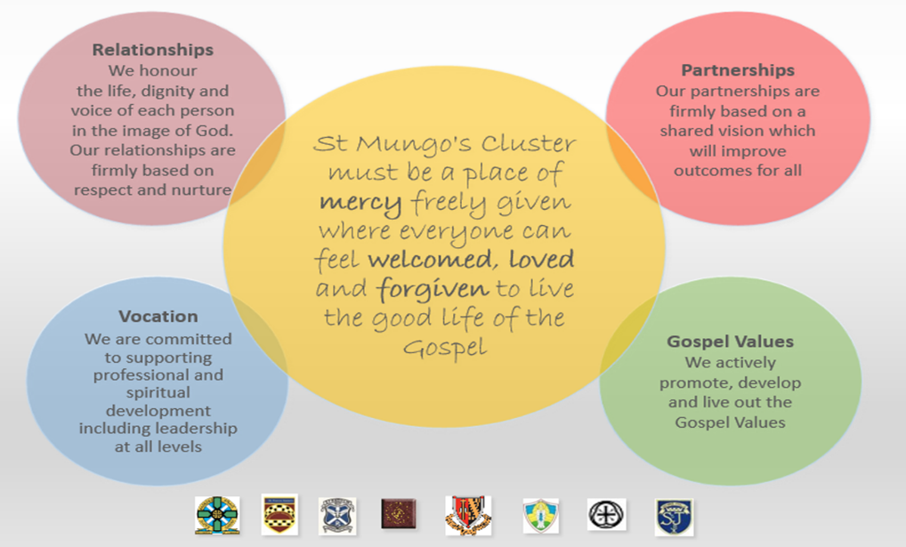

**St. Mungo’s Cluster**



**St Bernadette’s RC Primary**

**Standards and Quality Report**

**2016/17**

**2016 / 17**

**We wanted to:**

* Provide coherence and consistency in science across the cluster.
* Further develop curriculum pathways in literacy and numeracy as effective tools for planning and assessment.
* Improve the consistency in teaching and learning across the cluster by participating in practitioner research in numeracy.
* Adopt a nurturing schools approach, incorporating Food for Thought.
* Increase staff awareness of Making Thinking Visible teaching and learning approaches.

|  |  |
| --- | --- |
| **How Did We Do?** | **How do we know?** |
| **Science**  Following a residential course, working group staff planned, resourced and delivered professional learning workshops to all cluster staff.    All pupils completed questionnaires and have stated that the active, practical activities led to exploring new concepts. | Positive feedback indicated that the workshops and resources resulted in staff gaining new and interesting ideas for their class and have been able to build their confidence in delivering science lessons, raising the profile of science across the cluster.  Working with practical equipment led to greater engagement in the learning. |
| **Curriculum Pathways** We now have a consistent framework to planning and assessment of children’s progress within literacy and numeracy, from Nursery to S2, across the cluster. | All cluster schools have Literacy and numeracy pathways with benchmarks ready for planning next session. All staff are confident in the need for flexibility when using pathways and will plan to meet the needs of all pupils. This has greatly increased staff confidence and development of shared understanding of breadth, challenge and application within curriculum design. |
| **Practitioner Research into Numeracy** Action based research to improve levels of attainment was carried out within every Primary 7 class through investigating the impact of the use of concrete material to engage learner interest within fractions. | High quality professional learning was valued by all members and those invited in to support the programme by creating the resources. These resources to support the teaching of fractions, *Physical Fractions*, were created and given to all schools. Almost all P7 teachers made improvements to their practice and initial findings show an increase in attainment for most pupils who completed the series of lessons. Very positive feedback received from both P7 pupils and teachers. Those on the group participated in an evaluation of the programme that informed the research paper submitted by the lead Educational Psychologists. All practitioners in primary schools to undertake practitioner research to reduce attainment gaps in numeracy in session 17/18. |
| **Nurture** All practitioners received Royal Environmental Health Institute of Scotland (REHIS) training and certification and the primary programme was delivered successfully to Primary 4 by specialist teachers from the Home Economics department. All schools are using online Boxall Profiling for individual pupils for social, emotional and behavioural difficulties. This provides a consistent assessment and analysis of pupil needs, including pupils at times of transition. | As schools are at various stages with targeting the nurturing principles, individual schools will take forward nurture next session.  S1 nurture group has been established for 2017/18 using the information from Boxall profiling. This lead to a Summer transition programme for targeted pupils. Following moderation exercises and planned interventions there is a greater consistency and shared understanding across the cluster in supporting pupils at times of transition. |
| **Making Thinking visible** Most cluster schools have introduced a selection of routines to enable both staff and pupils to become familiar with the Making Thinking Visible strategies. | It has been observed that the quality of discussion and questioning has greatly improved. The children’s ability to make links and think of the bigger picture through the ethos of the routines has enabled them to engage more readily with lessons. The quality of the dialogue between the children is far richer. |