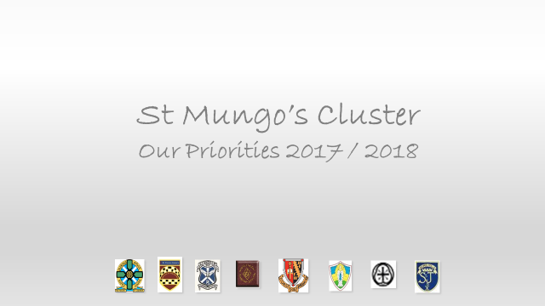

St. Bernadette’s Primary School

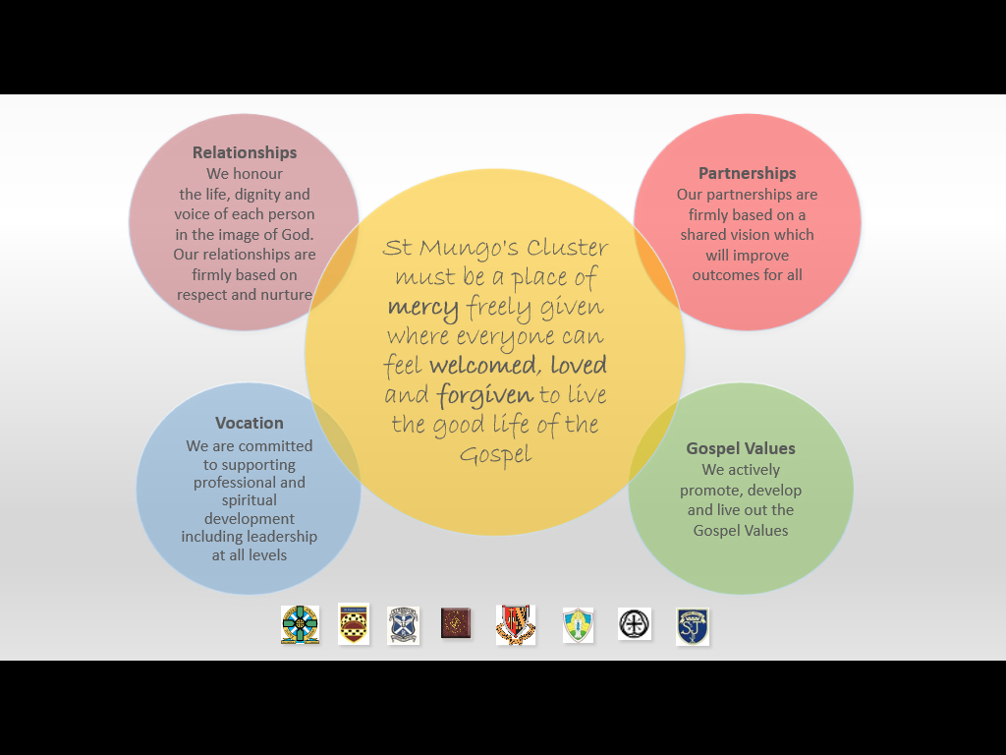
SELF EVALUATION
We understand that self-evaluation is an integral aspect of our approach to continuous improvement
We engage regularly in effective quality improvement and moderation activities and have agreed standards and expectations.
Our self-evaluation focuses on key aspects of learners’ successes and achievements.
We regularly review and analyse a wide range of data, supporting us to make informed decisions about future improvements.

We use HGIOS 4, National Improvement Framework and Developing in Faith as our toolkit for self-evaluation & continuous improvement

CURRICULUM |  |  | ATTTAINMENT/ACHIEVEMENT |  |  | PEDAGOGY
HGIOS4  2.2 CURRICULUM  2.7 PARTNERSHIPS  3.1 ENSURING WELL-BEING, EQUALITY & INCLUSION | NIF | DEVELOPING IN FAITH  SERVING THE COMMON GOOD | HGIOS 4  2.4 PERSONAL SUPPORT  2.3 ASSESSMENT  3.2 ATTAINMENT  2.6 TRANSITIONS | NIF  ASSESSMENT OF CHILDREN’S PROGRESS;  PERFORMANCE INFORMATION;  SCHOOL  IMPROVEMENT | DEVELOPING IN FAITH | HGIOS 4  1.2 LEADERSHIP OF LEARNING | NIF  TEACHER PROFESSIONALISM | DEVELOPING IN FAITH  DEVELOPING AS A COMMUNITY OF FAITH & LEARNING
We commit to communicate Catholic social teaching and thereby to promote social justice and opportunity for all  We plan a coherent and progressive approach to sustainability within the BGE  We offer all stakeholders a coherent and progressive curriculum within the 4 contexts  We enhance our children’s learning experiences by adopting a creative and innovative approach to curriculum design.  All staff and partners provide very good opportunities to develop children and young people’s skills for learning, life and work in motivating contexts for learning.  There is a clear focus on developing skills of literacy, numeracy, health and wellbeing across learning  We plan flexible learning pathways which lead to raising attainment through meeting the needs and aspirations of all our learners |  |  | All children and young people are benefitting from high quality universal support  We use a variety of assessment approaches to allow learners to demonstrate their knowledge and understanding, skills, attributes and capabilities in different contexts across the curriculum.  As a result of our manageable processes to monitor and evaluate learners’ progress we have clear information on their attainment across all curricular areas  Across all curriculum areas we raise attainment continuously over time and/or maintain consistently high standards of attainment  Our targeted support builds on robust, embedded universal support.  Our cluster works with key partners to remove barriers to learning and provide an inclusive learning environment, focussing on closing the attainment gap for all.  We have a comprehensive, well-planned programme of transition arrangements in place.  All our learners consistently move into sustained positive destinations.  We recognise and celebrate the wider achievements of all.  Every child has the same opportunity to succeed, with a particular focus on closing the attainment gap for all learners |  |  | Children and young people are engaged in high quality learning and teaching opportunities using a wide range of learning environments and creative teaching approaches  All staff routinely engage in career-long professional and spiritual development to promote enquiring and coherent approaches which build and improve our practice  Across our cluster, an ethos of professional engagement and collegiate working is evident.  Staff engage in Collaborative Action Research when appropriate in order to impact on their professional learning.
SELF EVALUATION
2016/17 2017/18 2018/19
- On-going Cluster Task Brief Evaluation  - Staff engage in robust self-evaluation of Science and Listening/talking  - Headteachers report and update at Cluster Meetings  - Interpretation and analysis of data  - Boxall Profile | - Cluster School Review and Development Team validate progress of Improvement Plan  - Establish and implement evaluation processes through School Improvement Partnership trios  - Headteachers report and update at Cluster Meetings | - Cluster School Review and Development Team validate progress of Improvement Plan  - Establish and implement evaluation processes through School Improvement Partnership trios  - Headteachers report and update at Cluster Meetings
CURRICULUM |  |  | ATTTAINMENT/ACHIEVEMENT |  |  | PEDAGOGY
HGIOS4  2.2 CURRICULUM  2.7 PARTNERSHIPS  3.1 ENSURING WELL-BEING, EQUALITY & INCLUSION | NIF | DEVELOPING IN FAITH  SERVING THE COMMON GOOD | HGIOS 4  2.4 PERSONAL SUPPORT  2.3 ASSESSMENT  3.2 ATTAINMENT  2.6 TRANSITIONS | NIF  ASSESSMENT OF CHILDREN’S PROGRESS;  PERFORMANCE INFORMATION;  SCHOOL  IMPROVEMENT | DEVELOPING IN FAITH | HGIOS 4  1.2 LEADERSHIP OF LEARNING | NIF  TEACHER PROFESSIONALISM | DEVELOPING IN FAITH  DEVELOPING AS A COMMUNITY OF FAITH & LEARNING
2016/17  - Implement Year 1 of SSERC project  - Further develop St Mungo’s Cluster Curriculum Pathways across all curriculum areas |  |  | - Moderation of Writing  - Support for targeted SIMD/others for numeracy to “close the gap” |  |  | - Cluster culture of peer support and challenge  - Roll out Making Thinking Visible across within/across all schools  - Adopt a “Nurturing School Approach” incorporating Food for Thought
2017/18  - Implement Year 2 of SSERC project  - Evaluate impact on Music / PE  - Audit how we work with partners to develop agreed skills for learning, life and work |  |  | - Shared understanding of achieving a Level within literacy and numeracy.  - Implementation of standardised assessment |  |  | - Staff engage in Collaborative Action Research within numeracy.  - Further develop Nurturing School approach.  - Growth Mindset
2018/19  - Implement Year 3 of SSERC project |  |  | - Intelligent use of data to support all transitions with targeted support  - Consistent approach to planning and tracking pupil attainment in the primaries |  |  | - Further develop Nurturing School approach, including Growth Mindset  - Creativity  - Continue Growth Mindset

Performance Information | St Mungo’s Cluster Priorities | School Leadership
HGIOS?4: 1.1,2.3,3.2 | Overarching strategic outcomes for 2017 -18 | HGIOS?4 : 1.1, 1.2,1.3,1.4,1.5
IfE 12: Research and evaluation to monitor impact | IfE 2: Social and Emotional Wellbeing  IfE 3: Promoting healthy lifestyles | IfE 9:Engaging beyond the school  IfE
Evaluate impact of music/PE cluster model | Schools continue to develop nurturing approaches.  Introduction of Growth Mindset to increase pupil engagement and resilience.
School Improvement | 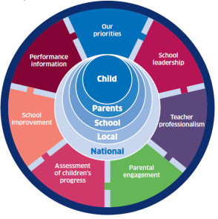 | Teacher Professionalism
HGIOS?4:1.1,1.2,1.3,2.2,2.3,2.4,2.5,3.2,3.3 |  | HGIOS?4: 1.1,1.2,2.1,2.4,2.7,3.1.3.2,3.3
IfE 1: Early intervention and prevention  IfE 4: Targeted approaches to literacy and  numeracy |  | IfE 5: Promoting a high quality learning  experience  IfE 11: Professional learning and leadership
All schools engaged in action based research to raise attainment in numeracy.  Schools individual PEF plans |  | Implement year 2 of SSERC  Further develop Early Years network
Assessment of children’s progress | Curriculum Rationale | Parental engagement
HGIOS?4: 2.3,2.4,3.2,3.3 |  | HGIOS?4: 2.1,2.2,2.3,2.4,2.5,2.6,2.7
IfE 6: Differentiated Support  IfE 7: Using evidence and data | IfE 8: Employability skills and development | IfE 10: Partnership working
Increase staff understanding of achievement of a level within literacy and numeracy.  Agree a policy for new SNSA. | Audit engagement with partners to agree skills for learning life and work. | Celebrate and promote the 1918 Education Scotland Act under the theme of “Jesus the Teacher”.
St Mungo’s CIP 1718
Outcomes and measures of impact

Key Outcomes | What are you going to measure and how will you do it?
Increase staff understanding of achievement of a level within literacy and numeracy.  Staff will engage in moderation and holistic assessments in line with national pathways and benchmarks across our cluster.  Increase confidence in teacher judgement.  Greater understanding of progression of learning and standards. | What?  Staff confidence and feedback through qualitative data gathering.( questionnaire)  HT feedback from planning and tracking meetings ( Standard item on agenda at HT meetings)  Raised attainment on achievement at all levels ( Tracking system x3)  How?  Cluster RACI established lead by Kate Delvin, with representatives from each establishment.  Advice and guidance for teaching with input from national QAMSO and Falkirk Council  Greater transition information to share as pupils progress using robust data on agreed revised  Cluster moderation events inviting staff feedback on improvements  Exemplars of holistic assessments shared on One Note
Introduction of Growth Mindset to increase pupil engagement and resilience.  Staff and pupil’s perception of themselves as learners and thinkers will increase. Research demonstrates that this will impact on learner confidence and resilience increasing engagement. | What ?  Baseline assessment of pupil engagement across all stages. ( Alan McLean’s Motivated School)  MALS (Myself as a Learner) for targeted groups.  Cluster feedback following implementation of Growth Mind-set approaches in individual schools.  (Standard item on agenda at HT meetings)  Staff feedback from PLC.  How ?  Cluster RACI established lead by Marianne Savage, with representatives from each establishment.  August 21st Staff development from John Paul Fitzpatrick, Winning Scotland Foundation, for all primary schools.  Establish a PLC to share good practice across our cluster.  Schools and individual teachers to develop approaches in their own settings, reflected in SIP.  Quality assurance in each establishment and shared at HT meetings.  Item on tracking and planning meetings.
All schools engaged in action based research to raise attainment in numeracy.  Staff will engaged in  Collaborative Action based Research (CAR) to close the gap the gap between theory and practice within Numeracy.  Increase pupil engagement, attitude and attainment. | What?  Research evidence for individual/ cohorts on small tests of change shared across cluster.  Raised attainment in numeracy connecting with Priority One.  How ?  Cluster RACI established lead by Tina O’Neill, with representatives from each establishment.  Input from Educational Psychologists on the importance of research and options of research models for staff. Schools use a CAT session to ensure staff understanding prior to research.  All staff to complete outline of research by December, implement January – March and cluster celebration event in of poster presentation (probationer model).

St. Bernadette’s Primary School

School Improvement 2017 - 2018

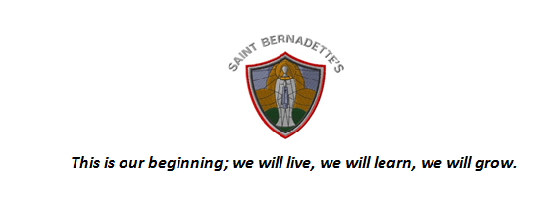
St Bernadette’s RC Primary School—The Rationale for our Curriculum
Our Curriculum Area and Subjects are:
- Well planned to ensure children experience a broad range of experiences across all curricular areas
- Experienced in a variety of context and environments including: school grounds, adopted land, Larbert Forest and other Falkirk venues.
- Evolving to ensure it is relevant and addresses Scottish , Falkirk, Stenhousemuir and Larbert contexts
- Designed to be coherent and progressive and develop strong literacy and numeracy skills
- Designed to ensure children access a broad range of enjoyable but challenging experiences in:
Expressive Arts * Language and literacy * Health and Wellbeing * Mathematics and numeracy * Religious and Moral Education * Sciences * Social Studies * Technologies
- Designed to provides opportunities for children to apply their learning from all of the subjects above in relevant interdisciplinary learning contexts
- Designed to provide opportunities for personalisation and choice for pupils within a structured framework
- Designed to Equip children with the skills for learning life and work to enable then to become:
Successful Learners * Confident individuals * Responsible citizens * Effective Contributors
Teaching for Effective Learning
- Consistently high teaching standards are expected throughout the nursery and school
- On-going reflection and self-evaluation ensures that we know how our pupils are progressing
- All staff regularly take part in professional learning to ensure our knowledge is continually updated
- All staff plan and collaborate to ensure smooth transitions for nursery to P1, class to class and P7 to S1
- All staff are outward looking to ensure we can learn from best practice
Values
St Bernadette’s RCPS will develop as a unique community of faith and learning. We will foster and promote the moral teachings of the Catholic Church. We will serve this community by providing an education of the highest quality for all children. Our curriculum will be vibrant and evolving to ensure we equip our children with lifelong skills to enable them to become happy fulfilled individuals.
Meeting Learners Needs
All staff are committed to:
- Planning learning to support and challenge all children; regardless of their ability
- Responding timely and appropriately to meet individual needs
- Supporting all pupils socially and emotionally and to recognise barriers to learning
- Work closely with partners and parents to ensure we address any additional support needs
Learners’ Experiences
In St Bernadette’s our Learners are:
- Engaged motivated and encouraged to contribute to the life of the school
- Encouraged to take responsibility for their learning
- Encouraged to share their views on their learning and in all aspects of school life
- Encouraged to be responsible and take leadership roles within their class, the wider school and the community
- Treated with respect to reflect SHANARRI wellbeing indicators
- Encouraged to promote Gospel Values in all aspects of their daily lives
St Bernadette’s RC Primary School Vision and Aims June 2013

Motto
This is our beginning; we will live, we will learn, we will grow.

Vision
St Bernadette’s RCPS will develop as a unique community of faith and learning. We will foster and promote the moral teachings of the Catholic Church. We will serve this community by providing an education of the highest quality for all children. Our curriculum will be vibrant and evolving to ensure we equip our children with lifelong skills to enable them to become happy fulfilled individuals.

Aims
We will deliver the aims and principles of Curriculum for excellence by:
- Helping children to develop a passion for learning by encouraging curiosity and creativity
- Ensuring that the teaching and learning is active and excites, inspires and captures our children’s imagination
- Ensuring staff and pupils think of themselves as life-long learners
- Working closely with parents, Church and the wider community to develop an establishment where everyone feels welcomed, valued and heard
- Developing as a ‘Rights Respecting School’ and foster an ethos of mutual respect and trust with high expectation of behaviour from all stakeholders
- Striving to continually raise levels of attainment whilst valuing and celebrating all achievement
- Allowing children to connect with nature, become more active, learn outdoors, develop social skills and have fun.
- Working with all stakeholders to ensure St Bernadette’s is a unique learning community where children live, learn and grow.

St Bernadette’s Nursery Class: Vision and Aims June 2013

Motto
This is our beginning; we will live, we will learn, we will grow.

Vision
St Bernadette’s Nursery will develop as a unique community of learning. We will serve this community by providing an education of the highest quality for all children. Our curriculum will be vibrant and evolving to ensure we equip our children with lifelong skills to enable them to become happy fulfilled individuals.

Aims
We will deliver the aims and principles of Curriculum for excellence by:
- Helping children to develop a passion for learning by encouraging curiosity and creativity
- Ensuring that the teaching and learning is active and excites, inspires and captures our children’s imagination
- Ensuring staff and pupils think of themselves as life-long learners
- Working closely with parents and the wider community to develop an establishment where everyone feels welcomed, valued and heard
- Developing as a ‘Rights Respecting School’ and foster an ethos of mutual respect and trust with high expectation of behaviour from all stakeholders
- Striving to continually raise levels of attainment whilst valuing and celebrating all achievement
- Allowing children to connect with nature, become more active, learn outdoors, develop social skills and have fun.
- Working with all stakeholders to ensure St Bernadette’s Nursery is a unique learning community where children live, learn and grow.

Performance Information | St Mungo’s Cluster Priorities | School Leadership
HGIOS?4: 1.1,2.3,3.2 | Overarching strategic outcomes for 2017 -18 | HGIOS?4 : 1.1, 1.2,1.3,1.4,1.5
IfE 12: Research and evaluation to monitor impact | IfE 2: Social and Emotional Wellbeing  IfE 3: Promoting healthy lifestyles | IfE 9:Engaging beyond the school  IfE
- Continue to develop nurturing approaches. (PEF Priority)
- To target improvement in all stakeholder’s level of engagement and resilience through Growth Mindset. (PEF Priority)
School Improvement |  | Teacher Professionalism
HGIOS?4:1.1,1.2,1.3,2.2,2.3,2.4,2.5,3.2,3.3 |  | HGIOS?4: 1.1,1.2,2.1,2.4,2.7,3.1.3.2,3.3
IfE 1: Early intervention and prevention  IfE 4: Targeted approaches to literacy and  numeracy |  | IfE 5: Promoting a high quality learning  experience  IfE 11: Professional learning and leadership
- To target improvement in numeracy and mathematics attainment through professional learning communities and Lesson study approach. (PEF Priority) |  | - Revisit LI/SC; effective feedback and learning conversations using the Moderation Cycle  - Continue to develop MTV
Assessment of children’s progress | Curriculum Rationale | Parental engagement
HGIOS?4: 2.3,2.4,3.2,3.3 |  | HGIOS?4: 2.1,2.2,2.3,2.4,2.5,2.6,2.7
IfE 6: Differentiated Support  IfE 7: Using evidence and data | IfE 8: Employability skills and development | IfE 10: Partnership working

St. Bernadette’s SIP 2017-18
Outcomes and Measures of Impact
Key Outcomes | What are you going to measure and how will you do it?
Continue to develop nurturing approaches throughout the school. | What?  - Apply nurturing approaches based around the 6 nurture principles  - Staff engagement in professional learning  - Research resources to support application of the 6 nurturing principles  - Use Ice Pack as a resource from nursery to P7  - Offer small nurture groups based on themes within the Ice Pack and nurture principles to support, for example, Lego therapy, Food for Thought, Circle of Friends  How?  - Use the ‘Applied Nurture Self-evaluation Process’ within Education Scotland Applying nurture as a whole school approach - A framework to support self-evaluation document  - Use Online Boxall Profiling for targeted pupils  - Track the number of playground incidents and behaviour referrals. Measure engagement and participation in learning using the Leuven Scale of Engagement
To target improvement in numeracy and mathematics attainment through professional learning communities and lesson study approach. (PEF Priority) | What?  - Raise pupil attainment in Numeracy and Mathematics  - Develop growth mathematical mindset in staff, pupil and parents  - Build capacity of staff and enhance collaboration through professional learning communities  - Promote high quality family learning to support raising attainment  How?  - PLCs - Every fortnight within CfE Level groups. Continuous cycle of identifying problematic mathematical concepts through analysing assessment data, professional dialogue and research, pedagogy and strategies identified and implemented, new assessment data gathered and attainment impact discussed. Assessment data will be a range of formative and summative  - Growth Mindset measured through ‘Myself As a Learner’ and Leuven Scale of Engagement  - Invite parents/carers to observe teaching and provide home link resources to encourage home engagement. Encourage parental engagement to produce support cues in various formats. Encourage parents/carers to attend the drop in homework club with their child.
Revisit LI/SC; effective feedback and learning conversations using the Moderation Cycle | What?  - Professional development of planning, teaching and assessment  How?  - Survey staff confidence levels of each segment of the Moderation Cycle and plan professional development accordingly  - Identified areas will become targeted professional development and progress will be a focus within quality assurance procedures, such as, planning and tracking meetings, observation and Learning Walks

