St. Mungo’s Cluster
Our Priorities 2019/20

St Bernadette’s Primary School
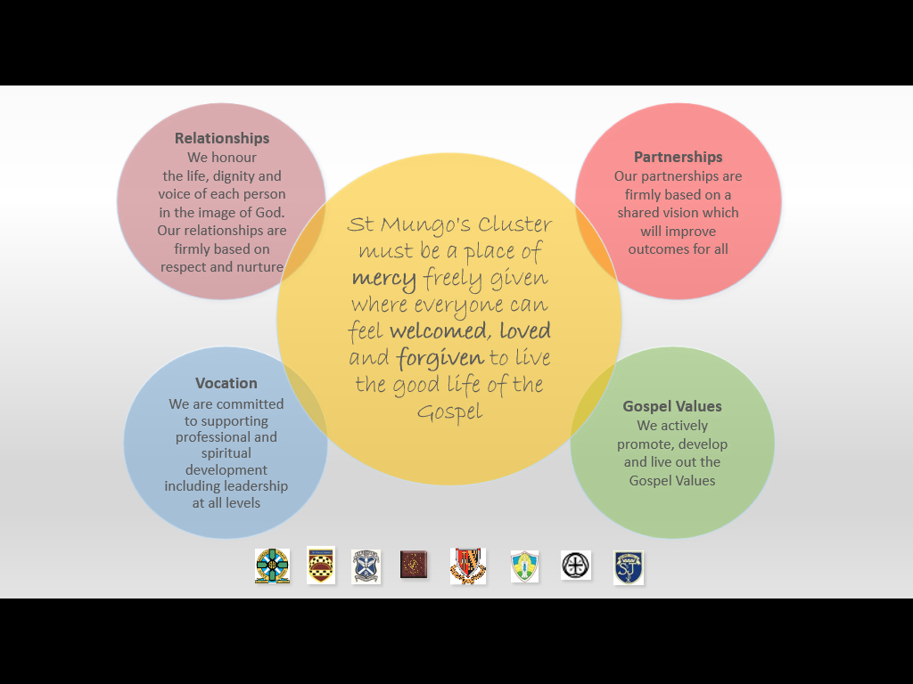
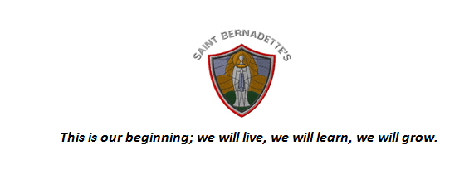
St Bernadette’s RC Primary School—The Rationale for our Curriculum
Our Curriculum Area and Subjects are:
- Well planned to ensure children experience a broad range of experiences across all curricular areas
- Experienced in a variety of context and environments including: school grounds, adopted land, Larbert Forest and other Falkirk venues.
- Evolving to ensure it is relevant and addresses Scottish , Falkirk, Stenhousemuir and Larbert contexts
- Designed to be coherent and progressive and develop strong literacy and numeracy skills
- Designed to ensure children access a broad range of enjoyable but challenging experiences in:
Expressive Arts * Language and literacy * Health and Wellbeing * Mathematics and numeracy * Religious and Moral Education * Sciences * Social Studies * Technologies
- Designed to provide opportunities for children to apply their learning from all of the subjects above in relevant interdisciplinary learning contexts
- Designed to provide opportunities for personalisation and choice for pupils within a structured framework
- Designed to Equip children with the skills for learning life and work to enable them to become:
Successful Learners * Confident individuals * Responsible citizens * Effective Contributors
Teaching for Effective Learning
- Consistently high teaching standards are expected throughout the nursery and school
- On-going reflection and self-evaluation ensures that we know how our pupils are progressing
- All staff regularly take part in professional learning to ensure our knowledge is continually updated
- All staff plan and collaborate to ensure smooth transitions for nursery to P1, class to class and P7 to S1
- All staff are outward looking to ensure we can learn from best practice
Values
St Bernadette’s RCPS will develop as a unique community of faith and learning. We will foster and promote the moral teachings of the Catholic Church. We will serve this community by providing an education of the highest quality for all children. Our curriculum will be vibrant and evolving to ensure we equip our children with lifelong skills to enable them to become happy fulfilled individuals.
Meeting Learners Needs
All staff are committed to:
- Planning learning to support and challenge all children; regardless of their ability
- Responding timely and appropriately to meet individual needs
- Supporting all pupils socially and emotionally and to recognise barriers to learning
- Work closely with partners and parents to ensure we address any additional support needs
Learners’ Experiences
In St Bernadette’s our Learners are:
- Engaged motivated and encouraged to contribute to the life of the school
- Encouraged to take responsibility for their learning
- Encouraged to share their views on their learning and in all aspects of school life
- Encouraged to be responsible and take leadership roles within their class, the wider school and the community
- Treated with respect to reflect SHANARRI wellbeing indicators
- Encouraged to promote Gospel Values in all aspects of their daily lives

SELF EVALUATION
We understand that self-evaluation is an integral aspect of our approach to continuous improvement
We engage regularly in effective quality improvement and moderation activities and have agreed standards and expectations.
Our self-evaluation focuses on key aspects of learners’ successes and achievements.
We regularly review and analyse a wide range of data, supporting us to make informed decisions about future improvements.

We use HGIOS 4, National Improvement Framework and Developing in Faith as our toolkit for self-evaluation & continuous improvement

CURRICULUM |  |  | ATTTAINMENT/ACHIEVEMENT |  |  | PEDAGOGY
HGIOS4  2.2 CURRICULUM  2.7 PARTNERSHIPS  3.1 ENSURING WELL-BEING, EQUALITY & INCLUSION | NIF | DEVELOPING IN FAITH  SERVING THE COMMON GOOD | HGIOS 4  2.4 PERSONAL SUPPORT  2.3 ASSESSMENT  3.2 ATTAINMENT  2.6 TRANSITIONS | NIF  ASSESSMENT OF CHILDREN’S PROGRESS;  PERFORMANCE INFORMATION;  SCHOOL  IMPROVEMENT | DEVELOPING IN FAITH | HGIOS 4  1.2 LEADERSHIP OF LEARNING | NIF  TEACHER PROFESSIONALISM | DEVELOPING IN FAITH  DEVELOPING AS A COMMUNITY OF FAITH & LEARNING
We commit to communicate Catholic social teaching and thereby to promote social justice and opportunity for all  We plan a coherent and progressive approach to sustainability within the BGE  We offer all stakeholders a coherent and progressive curriculum within the 4 contexts  We enhance our children’s learning experiences by adopting a creative and innovative approach to curriculum design.  All staff and partners provide very good opportunities to develop children and young people’s skills for learning, life and work in motivating contexts for learning.  There is a clear focus on developing skills of literacy, numeracy, health and wellbeing across learning  We plan flexible learning pathways which lead to raising attainment through meeting the needs and aspirations of all our learners |  |  | All children and young people are benefitting from high quality universal support  We use a variety of assessment approaches to allow learners to demonstrate their knowledge and understanding, skills, attributes and capabilities in different contexts across the curriculum.  As a result of our manageable processes to monitor and evaluate learners’ progress we have clear information on their attainment across all curricular areas  Across all curriculum areas we raise attainment continuously over time and/or maintain consistently high standards of attainment  Our targeted support builds on robust, embedded universal support.  Our cluster works with key partners to remove barriers to learning and provide an inclusive learning environment, focussing on closing the attainment gap for all.  We have a comprehensive, well-planned programme of transition arrangements in place.  All our learners consistently move into sustained positive destinations.  We recognise and celebrate the wider achievements of all.  Every child has the same opportunity to succeed, with a particular focus on closing the attainment gap for all learners |  |  | Children and young people are engaged in high quality learning and teaching opportunities using a wide range of learning environments and creative teaching approaches  All staff routinely engage in career-long professional and spiritual development to promote enquiring and coherent approaches which build and improve our practice  Across our cluster, an ethos of professional engagement and collegiate working is evident.  Staff engage in Collaborative Action Research when appropriate in order to impact on their professional learning.

Performance Information | St Mungo’s Cluster Priorities | School Leadership
HGIOS?4: 1.1,2.3,3.2 | Overarching strategic outcomes for 2019/20 | HGIOS?4 : 1.1, 1.2,1.3,1.4,1.5
IfE 12: Research and evaluation to monitor impact | IfE 2: Social and Emotional Wellbeing  IfE 3: Promoting healthy lifestyles | IfE 9:Engaging beyond the school  IfE
- Develop a shared understanding of wellbeing, equality and inclusion leading to positive impact on relationships and wellbeing of all
- Develop a shared knowledge and understanding of emotional literacy across the school community
- Targeted pupils will show an increase in self-regulation and emotional literacy
School Improvement | 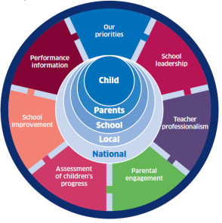  PEF Intervention | Teacher Professionalism
HGIOS?4:1.1,1.2,1.3,2.2,2.3,2.4,2.5,3.2,3.3 |  | HGIOS?4: 1.1,1.2,2.1,2.4,2.7,3.1.3.2,3.3
IfE 1: Early intervention and prevention  IfE 4: Targeted approaches to literacy and  numeracy |  | IfE 5: Promoting a high quality learning  experience  IfE 11: Professional learning and leadership
- 100% of pupils will show an increase by at least 10% in attainment within writing  - Assessment is for Learning- Feedback – will be used effectively to improve learning and teaching within writing  - Targeted approach to raising attainment in reading literacy through Fresh Start programme and Nessy  - There will be an increase of 10% in the number of children achieving first level at the end of P4 |  | - Further develop play based approaches within P2 to provide learners with the opportunity to engage in high quality rich learning experiences within literacy and numeracy to support curiosity, inquiry and creativity, leading to improved attainment.  - Learners will have opportunities to engage in high quality STEM experiences across and through the curriculum.  - Develop STEM in the outdoors in partnership with Under The Trees, working towards achieving the John Muir award from P4-P7
Assessment of children’s progress | Curriculum Rationale | Parental engagement
HGIOS?4: 2.3,2.4,3.2,3.3 |  | HGIOS?4: 2.1,2.2,2.3,2.4,2.5,2.6,2.7
IfE 6: Differentiated Support  IfE 7: Using evidence and data | IfE 8: Employability skills and development | IfE 10: Partnership working
- Develop a bank of moderated and quality assured literacy and numeracy holistic assessments for each level  - Continue to engage in school and cluster moderation events |  | - Targeted support with Under the Trees for identified P6/7 pupils to build resilience, perseverance and build positive relationships  - Develop STEM partnerships across sectors

Improvement Priority: Writing
What data / evidence informs this priority? | Outcomes (Detail targets % etc. 17/18, 18/19, 19/20) | Interventions  ( Interventions supported by PEF should be in Bold) | Expected Impact | Measures  (What on-going information will demonstrate progress? (Qualitative, Quantitative - short / medium / long term data) | Actual Impact
Teacher judgement indicates that an average of only 73% of pupils are ahead or on track for writing attainment.  SNSA  Staff indicate writing is an area of the curriculum where they require further professional development.  Performance data of P1, P4 and P7 teacher judgement gathered in 17/18 is below both the neighbourhood group and local authority.  Pupil survey June 2019 shows that -  51% of pupils enjoy writing lessons  66% feel they are making good progress in writing  37% know their next steps and how to improve their writing | By May 2020, 85% of learners will be on track in writing attainment. | CLPL for all staff in Talk 4 Writing approach to fictional writing  Consultancy support through Talk 4 Writing:  • Planning and review  • Leadership development  • Developing whole school  systems  • Talk for Writing planning  workshops – fictional writing  • In class support and coaching  • 1 to 1 staff surgery sessions  Implement and resource  Further develop our understanding of quality feedback through professional learning opportunities  The 5 critical questions (Lynn Sharrat) will become the focus for quality assurance procedures during writing:  - What are you learning?  - How are you doing?  - How do you know?  - How can you improve?  - Where do you go for help? | 100% of staff will report:  - An increase in confidence to teach writing.  - An increase in knowledge of effective writing pedagogy.  Clearly identified action points for development bespoke to our school  Clear, progressive framework for writing across the school  Increased pupil engagement during writing lessons  Increased pupil writing attainment  100% of staff demonstrate quality feedback that impacts on the teaching and learning of writing  At least 75% of pupils will be able to report on their progress in writing and identify their next steps  At least 80% of pupils will be able to report that they feel they are making good progress within writing | Outcome Measure  - Teacher judgement  - Assessment data  - SNSA  - Performance data within neighbourhood and authority  Process Measures  - Staff audit on competency and skill within the teaching of writing – pre and post;  - Termly tracking meetings  - Talk 4 Writing baseline audit  - Evidence from Talk 4 Writing initial consultation  - review of the impact of Fiction input, leadership Support and teacher  support (Talk 4 Writing)  - Assessment and moderation of writing  - Leuven scale of engagement  - Learning walks  - Class observations  - Jotter moderation  - Pupil focus groups  - Pupil survey – taken at 4 points throughout the session  Balance Measure:  - Writing across the curriculum

Improvement Priority: Wellbeing for All
What data / evidence informs this priority? | Outcomes (Detail targets % etc. 17/18, 18/19, 19/20) | Interventions  ( Interventions supported by PEF should be in Bold) | Expected Impact | Measures  (What on-going information will demonstrate progress? (Qualitative, Quantitative - short / medium / long term data) | Actual Impact
Pupil SHANARRI questionnaires issued in March, indicate that on average 64% of pupils feel safe in school; 65% consider themselves to be healthy; 78% feel they are achieving; 65% feel nurtured; 72% consider themselves as active; 70% feel respected; 71% feel responsible and 73% feel included.  Record of incidents requiring adult intervention highlights the need to target individual pupils to develop strategies to self-regulate their emotions.  Develop as a community of faith and learning, serving the common good through communicating Catholic social teaching to promote social justice opportunity for all, enabling young people to develop their understanding of Gospel values and of how to apply them to life | 100% of targeted pupils will show an increase in self-regulation and emotional literacy by May 2020. | Staff professional learning in Emotion Works  Emotion Works will be used universally to increase emotional literacy  Emotion Works framework will be used to assist targeted pupils to increase self-regulation strategies  Progressive framework of universal approaches within the H&WB curriculum, e.g, This Is Our Faith, God’s Loving Plan, Ice Pack, Equality and Inclusion SCES framework, SHANARRI Indicators, positive relationships policies  Implement a consistent approach to the tracking of wellbeing  All schools to participate in Compassionate and Caring Community programme  Work with the school community to promote a positive playground leading to greater feelings of safety, inclusion and wellbeing.  Targeted support with Under the Trees Forest School weekly sessions for identified P6/7 pupils to build resilience, perseverance and build positive relationships | 100 % of staff report a secure knowledge and understanding of Emotion works Framework  100% of targeted pupils show an increase in emotional literacy  100% of targeted pupils show an increase in self-regulation  All staff, parents and pupils have a shared understanding to support wellbeing equality and inclusion leading to a positive impact on the relationships and well-being of all  All cluster schools use a consistent and shared approach to tracking wellbeing, identifying staged intervention for wellbeing and signposting  appropriate support  An inclusive ethos which aims to honour the life, dignity and voice of each person, made in the image of God  Targeted pupils will demonstrate increased resilience and perseverance both within the Under the Trees Forest School sessions and across the curriculum | Outcome Measure  - Number of incidents where adult intervention to self-regulate is required  Progress Measure  Universal:  - Pre and post staff questionnaire  - Planning and Tracking meetings  - Gather data regarding:  - The number of incidents SfLA deal with in the playground  - Reported incidents to teachers from pupils following interval and lunch  - Pupils feelings towards lunch – positive or negative  Targeted:  - Restorative discussions recorded using the Emotion Works framework  - Data captured within tracking of wellbeing will inform next steps for individual schools  - Leuven scale of engagement for targeted Under the Trees Forest School pupils  - Targeted Under the Trees Forest School pupils will self-scale resilience and perseverance using the Challenge-O-Meter following weekly sessions  Balance Measure  - Increased engagement across the curriculum

Improvement Priority : STEM
What data / evidence informs this priority? | Outcomes (Detail targets % etc. 17/18, 18/19, 19/20) | Interventions  ( Interventions supported by PEF should be in Bold) | Expected Impact | Measures  (What on-going information will demonstrate progress? (Qualitative, Quantitative - short / medium / long term data) | Actual Impact
HT knowledge and observations have highlighted the lack of consistency in the teaching and learning of STEM subjects. Only 20-30%  STEM is a Falkirk Council priority for improvement.  Broad General Education and Senior Phase lack progression and consistency in approaches  There is a lack of consistency in use of the Science Box resource in the Primary Schools. | 100% of learners will have opportunities to engage in high quality STEM experiences across and through the curriculum. | Professional Learning  - All Primary School Teachers will undertake self-evaluation using the Education Scotland Toolkit as a baseline.  - Staff will engage in CLPL at local Authority and Cluster level  Partnerships  - Collaboration across the sector with Science, Technology, Engineering and Mathematics in St Mungo’s involving team teaching and STEM Ambassadors  - Collaboration with Education Scotland and DYW Forth Valley and RIC STEM leads to engage partnerships  Learning through STEM  - All IDL for this session will be STEM based covering the five main Science themes: Biodiveristy and Interdependency, Electricity, Vibration and Waves, Body Systems and Cells, Energy and Forces.  - IDL planners will include pupil voice and will be shared across schools.  - All teachers will moderate planning for STEM learning across the cluster  - Develop STEM in the outdoors in partnership with Under The Trees, working towards achieving the John Muir award from P4-P7  A showcase event to celebrate the outcome  Family Learning  - STEM Vocational Programme (a 5 week family learning programme). | Increased teacher confidence in the planning and delivery of STEM subjects. Increased use of the Science Boxes and other STEM resources  Greater knowledge of skills progression in STEM Subjects using National Benchmarks.  Greater knowledge of future skills: Creativity, Communication, Critical Thinking, Collaboration, Complex Problem Solving.  Sharing pedagogy and up-skilling of Primary Teachers by Subject Specialists and STEM Ambassadors.  Developing leadership skills through and across schools.  Professional collaboration and the shared understanding of quality STEM experiences.  Staff practice is cohesive with national aspirations of DYW and the Future Skills agenda.  Identify and establish a sustainable partner across the cluster.  Pupils will demonstrate increased engagement in IDL learning experiences, demonstrating the 5 critical skills.  There be an increased and consistent use of Science boxes across all Primary Schools.  Significant increase in STEM based learning across the curriculum.  A bank of IDL planners will be created, moderated and shared across schools.  The community event will take place to celebrate creativity within STEM.  STEM Vocational Programme aims to foster positive relationships between families whilst developing key skills for lifelong learning. | Outcome Measure  - Leuven scale (possible PDSA) targeted at Primary 5 learners including run charts.  - Learning walks using 5 critical questions with pupils and classroom observations with the average STEM lesson 4.5 or above.  - Quality assurance procedures.  - Feedback from all participants at the celebration event including requests for further partnership/support.  Process Measure  - Teacher self-evaluation, pre and post changes  - Level of staff engagement in STEM CLPL  - Staff confidence in planning and delivering STEM IDL  - Planning and tracking meetings and HT reporting back at Cluster Head meetings, including STEM lead from St Mungo’s  - Staff feedback  - Ambassadors questionnaires  - Increased level of partnership agreements.  - Pupil feedback including levels of engagement and challenge.  - Anecdotal feedback capturing inspiration, engagement and energy for STEM subjects from all stakeholders.  Balance Measure  - Impact on social subjects.

Improvement Priority: Creativity
What data / evidence informs this priority? | Outcomes (Detail targets % etc. 17/18, 18/19, 19/20) | Interventions  ( Interventions supported by PEF should be in Bold) | Expected Impact | Measures  (What on-going information will demonstrate progress? (Qualitative, Quantitative - short / medium / long term data) | Actual Impact
Conclusions and results from cluster improvement priority focussing on play in 2018/19 indicate:  - Planning rich learning experiences, which reflect pupils interest and prior learning, increases engagement and can impact positively on attainment.  - Play based learning is fundamental to developing children’s creativity and curiosity- supporting and enhancing their insight, problem solving, divergent thinking and the ability to express emotions.  - The added value of collaboration across schools and the wider authority to successfully support improvements within individual schools. | By June 2020 100% of P2 learners will have the opportunity to engage in high quality rich learning experiences within literacy and numeracy to support curiosity, inquiry and creativity, leading to improved attainment. | 100% of P2 staff will engage in CLPL opportunities to support their understanding of a developmentally appropriate pedagogy.  P2 CT’s will establish a cluster network to collaborate and support the improvements.  CT review and develop structure of the day to ensure an appropriate balance between, adult and child-initiated learning.  100% of P2 CT’s will design rich learning experiences within literacy and numeracy responding to children’s interests and prior learning.  CTs will plan open-ended tasks for children in literacy and numeracy. | I00% of P2 staff feel enabled and supported by management and cluster network to drive this aim forward.  100% of P2 pupils will demonstrate improved engagement, independence, interdependence, creativity and attainment in their learning. | Outcome Measure  - Learning Walks  - Planning and tracking meetings  - Classroom Observations  - Pupil observations.  - Teacher Judgement  Progress Measure  - Baseline confidence survey of staff Aug 2019 and post survey May 2020  - Teacher’s participation measured through scaling exercise beginning and end of each meeting.  - Structure and balance of day - visual representation of day. - 3xper session.  - Leuven scale of engagement and wellbeing linked to individual CT’s PDSA  - Boxall profile  Balance Measure  - Top 20% tracking information

Improvement Priority: Numeracy
What data / evidence informs this priority? | Outcomes (Detail targets % etc. 17/18, 18/19, 19/20) | Interventions  ( Interventions supported by PEF should be in Bold) | Expected Impact | Measures  (What on-going information will demonstrate progress? (Qualitative, Quantitative - short / medium / long term data)
Staff survey – planning for improvement.  Numeracy was identified as highest priority across the cluster.  Staff Practitioner enquiry – high levels of engagement and identified importance of collaboration across schools.  Attainment and Tracking results.  SNSA  Teacher Judgement  Classroom Observations.  Pressure point test results at P5 stage in session ‘18/19 for those who missed out on first level, identified problems with division and fractions.  Success of work done at P5 stage in session ‘18/19 was recognised and this is now being spread to start of P4 stage to ensure children are on track for first level rather than responding to groups of children not achieving a level.  SNSA data at start of P4 will help to focus target group in session ‘19/20 | In each school, there will be an increase of 10% in the number of children achieving first level at the end of P4 (by May ’20) | Targeted teaching block, at least once a week for ten weeks, focusing on concept gaps identified through triangulated data using SNSA, numeracy pressure point assessments and teacher judgment.  A range of core pedagogical approaches such as concrete/pictorial/abstract (supported by Numicon) and Number Talks.  Additional reinforcement of identified concepts through the use of MangaHigh three times weekly for identified pupils.  Cluster CAT session to be arranged for teaching staff focused on concrete/pictorial/abstract – Susan Thomson to deliver.  The Cluster Numeracy RACI group will launch the set of guidelines produced session ‘18/19 that will inform the consistent use of Mathematical Language across the cluster. Guidelines to be launched at Cluster CAT session in line with concrete/pictorial/abstract training | Each school will evidence a 10% increase in the number of children achieving first level.  100% of staff leading numeracy interventions to identified pupils will report an increase in their confidence levels in delivering lessons using the identified pedagogical approaches.  100% of cluster staff will be aware of the guidelines and a clear understanding on how to take this forward.  The guidelines will facilitate the consistent use of Mathematical Language across the cluster including the transition from P7 into S1. | Outcome Measure  - SNSA  - Teacher Judgement  Progress Measure  - Run chart to track progress through targeted  - Pre / post Pressure Point Numeracy assessments for identified pupils.  - Increase in frequency and improvement in pupil scores on MangaHigh through identified pupil engagement at least three times weekly.  - Wider contextual data also to be drawn upon to support teacher judgment e.g. snapshot jotters, Beat That Tests etc.  - Moderation of this should take place via the RACI group.  - Classroom Observation Learning Walks using the 5 critical questions to support engagement with pupils Pupil Learning Conversation  Balance Measure  - Increased attainment beyond the targeted group and the sharing of pedagogical approaches and resources across stages.

