Standards and Quality Report
St Mungo’s Cluster
ST. BERNADETTE’S PRIMARY SCHOOL
2018-2019

St Mungo’s Cluster

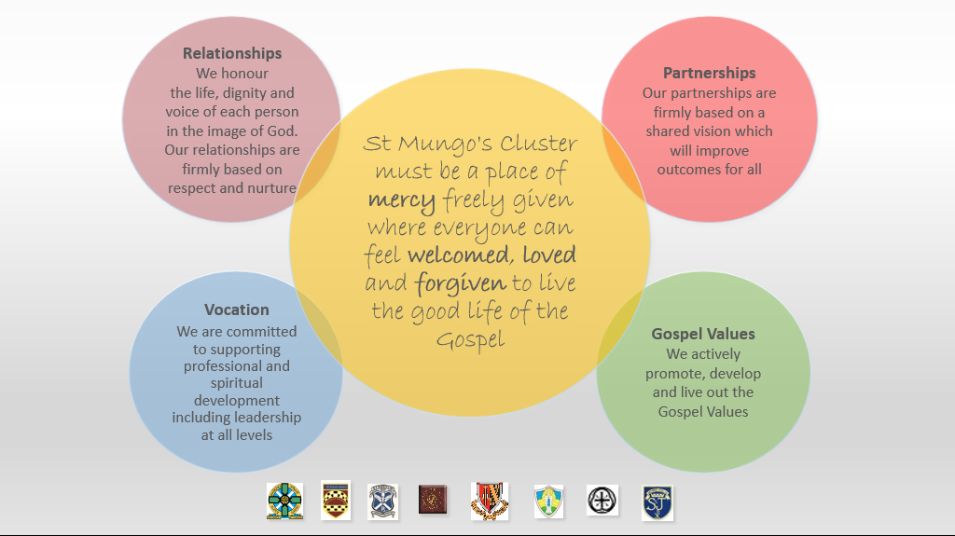

St Mungo’s Cluster consists of seven primary school and one secondary school and operates across Falkirk Council. As a denominational Cluster we work closely together to serve our communities of Faith and Learning.

Senior Management, staff, parents and pupils across all schools contributed to various self-evaluation exercises to contribute to this Standard and Quality Report. This included evaluating all improvement priorities for the session 2018/2019 using How Good is Our School? 4 and Developing in Faith. Staff, parent and pupil views were gathered for self-evaluation and to identify future improvements.

HMIe highlighted our Cluster Model for improvement and self-evaluation in a recent inspection stating our strong approach to cluster working is practice worth sharing. (March 2019.)

Our Context

St. Bernadette’s Primary fosters and promotes the moral teachings of the Catholic Church. We aim to serve the community of Stenhousemuir, Larbert, Carronshore and Carron by providing an education of the highest quality for all children. Our curriculum is vibrant and evolving to ensure we equip our children with lifelong skills to enable them to become happy fulfilled individuals.

Our current school role is 209 pupils in P1-7 and 40 children within our nursery class. We have 8 classes in total. Our school leadership team consists of Headteacher, Depute Headteacher and Acting Principal Teacher.

3% of our pupils receive free school meal entitlement.

The breakdown of data of where pupils live according to SMID index, where Decile 1 is most deprived and Decile 10 being least deprived is as follows:

Decile 1: 0.4%, Decile 2: 4%, Decile 3: 7%, Decile 4: 3%, Decile 5: 8%, Decile 6: 19%, Decile 7: 9%, Decile 8: 21%, Decile 9: 6% and Decile 10: 22%

During this session we received £18,000 of Pupil Equity Fund allocation.

Review of progress for 2018-19

Priority 1: 100% of identified pupils across the cluster, in P2 and P5, will show an increase of at least 20% in attainment in Numeracy Pressure Point assessments for Number and Number Processes by May 2019.
NIF Priority- Improve attainment in Numeracy and Closing attainment Gap  NIF Driver- Teacher professionalism | FC Priority  Improving Attainment
HGIOS?4/HGIOELC? QIs  2.3 Learning, teaching and Assessment | Has this work been supported by PEF? YES
Progress and impact

Digital learning resources including Mangahigh now being used across all primary schools in the cluster following staff training.
CLPL session for all primary staff on Number Talks delivered by Susan Thomson.
Parental and P5 classes workshop delivered by Chris from Mangahigh for all Cluster Schools. All staff participated in a staff webinar. Numeracy Working Group accessed additional data training from Mangahigh development team.
All staff more knowledgeable about implementing change that result in improvement in Number Talks. Quality assurance procedures demonstrate all staff have used approaches such as concrete, pictorial, abstract and Number Talk to influence change.
Collaboration between primary and secondary staff has led to a shared understanding of Mathematical language.
All pupils more engaged in a consistent approach to digital learning within Numeracy and tasks are assigned by teachers identifying gaps in learning.
Teachers report pupils’ growing confidence in articulating thought process in calculations.
Format for parental engagement that worked previously replicated but not as successful. On reflection, focus on communicating with parents was too narrow on this occasion and needs to emphasise raising of attainment and engagement.
Pressure point assessments have provided staff with greater confidence in judging achievement of level consistently and identifying gaps in learning and devising appropriate pedagogical interventions.
The identified aim outlined at the start of this project was met:
100% of pupils at P2 and P5 showed improvement of at least 20% in gaps identified through pressure point test
Use of pressure points is a useful assessment tool to focus interventions and share standards.

Next Steps
- Continue planning and pedagogical approaches across all learning i.e concrete, pictorial abstract and Number Talks.
- Use of pressure point assessment earlier in P4 in session 19/20 with SNSA data.
- Consistent approach to Mathematical language developed as an additional strand due to gaps identified in CLPL Number Talk session. This guidance will be available for use in session ‘19/20 through BGE.
- Continue to focus on targeted groups to build on success.

Review of progress for 2018-19

Priority 2 : Our community has a shared understanding of wellbeing equality and inclusion leading to a positive impact on the relationships and well-being of all by May 2019
NIF Priority- Health and Wellbeing  NIF Driver – Teacher Professionalism | FC Priority  Improvement in children’s and young people’s health and well being
HGIOS?4/HGIOELC? Qis  2.4 Personal Support  3.2 Inclusion and Wellbeing | Has this work been supported by PEF? Yes
Progress and impact

All children have an awareness of SHANARRI indicators following planned teaching and learning opportunities and have participated in regular reflections on their wellbeing.

Working party created a cluster approach to tracking health and wellbeing through developmentally appropriate questionnaires.

All staff engaged in continuous CLPL through engagement with Stan Godek and Local Authority ACEs input leading to a greater understanding of the impact of trauma.

All staff in St. Bernadette’s have undertaken professional development in Emotion Works to develop emotional literacy. The Emotion Works framework has been introduced to support pupils to articulate their emotional wellbeing.

All staff in St. Bernadette’s have undertaken professional development in de-escalation strategies leading to deeper understanding of behaviour in context.

A house system has been introduced into St. Bernadette’s promoting a sense of community amongst pupils.

Pupil SHANARRI questionnaires were issued to pupils within St. Bernadette’s in March. Results indicate that on average 64% of pupils feel safe in school; 65% consider themselves to be healthy; 78% feel they are achieving; 65% feel nurtured; 72% consider themselves as active; 70% feel respected; 71% feel responsible and 73% feel included.

Next Steps
- Pilot the health and wellbeing questionnaire in August/September 2019 to targeted groups. Following consultation with pupil and parent councils, full implementation across all stages will occur.
- Develop targeted intervention and signposting toolkit to respond to the data collected.
- Continue to develop the use of Emotion Works framework to support emotional wellbeing, assisting pupils to identify and implement self-regulation strategies.
- Work with the school community to promote a positive playground leading to greater feelings of safety, inclusion and wellbeing.

Review of progress for 2018-19

Priority 3: AiFL Feedback is used effectively to improve learning and teaching.

NIF Priority- Improve attainment  NIF Driver – Teacher professionalism | FC Priority  Improving attainment
HGIOS?4 /HGIOELC? QIs  2.3 Learning, teaching and assessment | Has this work been supported by PEF? No.
Progress and impact

The 5 critical questions (Lynn Sharrat) were adopted across all classrooms and were the focus for quality assurance procedures.

Almost all schools led improvements within their own establishments and collaborated and shared highly effective practice.

The working party developed a cluster rationale exemplar on effective feedback.

Across St. Mungo’s Cluster quality assurance procedures, including snapshot jotters, have shown an improvement in the quality of feedback given to children.

Next Steps
- The ideas, tests of change, and CLPL which has taken place across the cluster has been shared between establishments (electronic resources are available through Teams). Visits between establishments, with a view to sharing best practice, have already started to take place.
- Schools should continue to identify their own next steps, and use the identified skills, knowledge and experience across the cluster to support the implementation of change.
- The cluster rationale will be agreed and shared.
- Within St. Bernadette’s effective feedback will be developed to improve learning and teaching in writing.

Review of progress for 208-19

Priority 4: By June 2019, 100% of our P1 pupils will confidently demonstrate creative thinking, independence and high engagement in their learning through a developmentally appropriate play-based approach.
NIF Priority- Teacher professionalism  NIF Driver – Employability Skills | FC Priority  Raising attainment
HGIOS?4/HGIOELC? Qis  3.3 Creativity and Employability  2.3 Learning, Teaching and Assessment | Has this work been supported by PEF? YES
Progress and impact

The cluster working group successfully created a culture of professional collaboration and engagement in the wider authority sharing practice and training events. All P1 staff valued the high level of collaboration across schools and the wider authority to successfully support improvements within individual schools.
All P1 classes have improved the structure and balance of the day, which is now more focused on small group teaching and child-initiated play. There has been a reduction of whole class teaching and adult initiated play. "I like that it gives the children ownership of their own learning and increases their levels of independence and engagement." (Parent)
All P1 staff reviewed the physical layout of the classroom and adapted to support this approach. All P1 staff have a deeper understanding of child development and the importance of a play-based pedagogy.
All P1 staff have a greater knowledge of their pupils’ progress and the level of support and challenge required.
All schools committed to funding quality resources which facilitated open ended experiences. It also supported the physical environment of the room.
All P1 teachers understand the importance of carefully planning the layout and flexibility of classrooms/learning areas to ensure continuous provision and effective learning.
All P1 staff understand that effective planning and use of provocations are essential to encourage engagement, curiosity and motivation across Literacy, Numeracy and Health and Wellbeing.
100% of targeted pupils demonstrate higher engagement, independent learning, increased creativity and curiosity across learning as well as demonstrating higher levels of positive social interactions.(Leuvens).
Next Steps
- P1 class teachers will use Leuven's Scale of Engagement
- Review current planning process to reflect a more responsive approach to build on prior knowledge and children’s interests.
- Continue pedagogy into P2 and P3.
- CLPL and PDSA findings will be shared with all staff within each establishment.

Key priorities for School Improvement Planning 2019 -2020

St Mungo’s High School Cluster:

Priority 1: Creativity
By June 2019 100% of P2 learners will have the opportunity to engage in high quality rich learning experiences within literacy and numeracy to support curiosity, inquiry and creativity, leading to improved attainment. Within St. Bernadette’s the focus will be within writing.
Priority 2: Wellbeing for All
100% of targeted pupils will show an increase in self-regulation and emotional literacy by May 2020
Priority 3: Numeracy

100% of identified pupils across the cluster at P4 stage, will show an increase in Numeracy Pressure Point assessments for Number and Number Processes by May 2020

Priority 4: STEM
100% of learners will have opportunities to engage in high quality STEM experiences across and through the curriculum.
St Bernadette’s Priority: Writing
100% of learners will show a 10% increase in writing attainment
What is our capacity for continuous improvement?

We continue to build on our strong commitment to cluster collaboration and improvement impacting on all children and families within our denominational schools. Staff feedback from cluster wide professional learning evidenced this approach is highly valued. Distributed leadership is prioritised, and opportunities will continue to be provided for staff. Our model facilitates sharing of good practice, resources and robust moderation across learning. Our drive for consistency in pedagogy, tracking of attainment and achievement and approaches will lead to better outcomes for all.

Self-Evaluation of the Core HGIOS?4/HGIOELC? QIs
1.3 | Good
2.3 | Good
3.1 | Good
3.2 | Good

