Dear Parents/Guardians,

Christmas Early Closure

I would like to inform you that the school will close for the Christmas holidays at 1.30pm on Tuesday 21st of December. The school buses will collect the children at.1.30pm.

If you intend to take your child home for lunch at 12.15pm, they will be released via their classroom door. Please note that pupils can only be collected at 12.15pm sharp. Any child not collected at this time will remain in school until 1.30pm. Please do not try to collect your child at any time other than 12.15pm or 1.30pm.
Please remind the person responsible for collecting your child that
we close at 1.30pm.

Pupils who are staying until 1.30pm can either order a lunch as normal or bring a packed lunch with them.

Lunches must be pre-ordered; therefore I would ask that you please complete the slip below. Any slips returned after this day will not be included and your child will have to bring their own packed lunch.

The school will re-open on Wednesday 5th of January 2022 at 9.00am.

On behalf of all staff at St. Bernadette’s Primary School and Nursery I would like to take this opportunity to thank you all for your continued support and wish you all a very Merry Christmas and a Happy and Healthy New Year.

Yours sincerely,
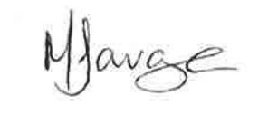
Marianne Savage,
Headteacher.

----------------------------------------------------------------------------------------------------------------------
Christmas Early Closure

Child’s name ……………………………………………………….. Class: ………………...

The above named child will require a school lunch on Tuesday 21st of December.

Cheese Panini

Signed: ……………………………………………………………

