St Bernadette’s RC Primary School
Edward Avenue, Stenhousemuir, FK5 4XR
01324 503400 | StBernadettesPrimarySchool@education.falkirk.sch.uk
Headteacher: Mrs Marianne Savage

Dear Parent/Carer,

I am writing to invite you to our Scottish Celebration (official invite to follow) on Thursday 5th February 2026.at 6pm.

If you wish to attend, please complete and return the tear off slip below to indicate the number of tickets you require (2 per family). Extra tickets may become available.This year we are delighted to inform you that Three Little Pigs are providing the catering for this event, therefore we are asking for £5 per adult (no cost to children) to cover the cost. Payment should be made on Ipayimpact (no cash handed into school). We also would like to take the opportunity to thank Mrs Lawless-Mitchell for organising the donation of Irn Bru from A.G. Barrs.

Please ensure you return your food order below by Friday 16th January to allow us to give Three Little Pigs numbers.

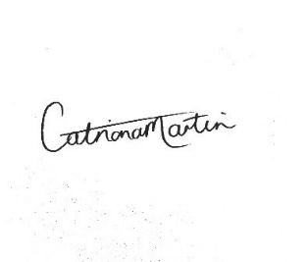
We hope you are able to join us for an evening of entertainment, music, dancing and a taste of Scotland (haggis, neeps & tatties and Irn Bru)!

Yours sincerely.

Mrs Martin,
Teacher.

-----------------------------------------------------------------------------------------------------------

Scottish Celebration – Thursday 5th February 2026

Child’s Name ……………………. Number of tickets required

No. of traditional haggis meals No. of vegetarian haggis meals

Please inform us of any dietary requirements…………………………………

I agree to pay £5 per adult on Ipayimpact

PLEASE DO NOT SELECT FOR YOUR CHILD/CHILDREN. WE WILL ORDER PUPILS’ CHOICES IN CLASS.

Signed …………………………………………….

Relationship to child ……………………………

